10. Lookup Relationships - 08 March 2022

1] Lookup Relationships



2] Difference between Master-Details Relationship and Lookup Relationships.



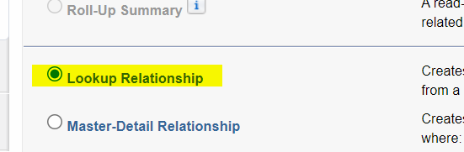

Status : New, In Progress, Completed, Rejected, Hold

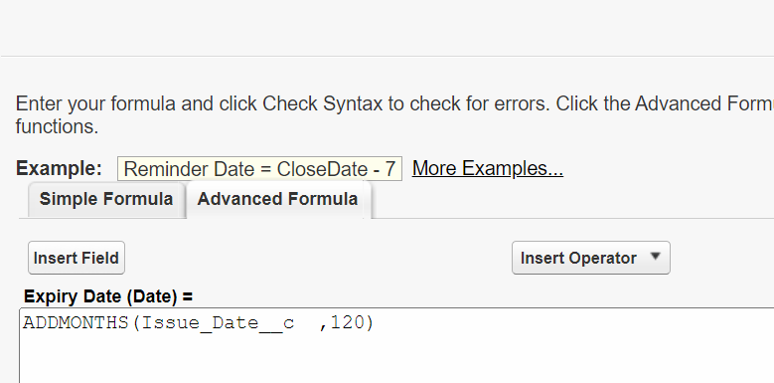

POINTS TO REMEMBER:

|  |  |
| --- | --- |
| Master-Details Relationship | Lookup Relationships |
| 1] Master is mandatory while creating details records. (Tightly Coupled) | 1] Parent is **NOT** mandatory while creating Child records. (Loosly Coupled) |
| 2] When we delete Master Record, then all the related details records get deleted Cascadingly. | 2] When we delete Parent Record, then all the related child records **NOT** get deleted Cascadingly. |
| 3] There should be no any record exists in Details Object while creating Master-Details Relationship. | 3] No Problem |
| 4] We can create Rollup Summary Field on Master Side. | 4] Rollup Summary field is Not Available ON Parent Object. |

===========================================================================================

1] There are two object, Applicant and Address. Relationship is in Master-Details. Can we convert this relationship into Lookup Relationship. (Master Details 🡪 Lookup)

**Ans**: YES, But 🡪 There should NOT be any Rollup Summary exists on the Master object.

Address Object:

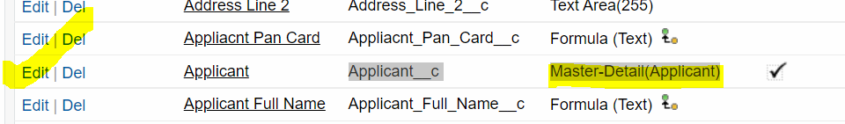

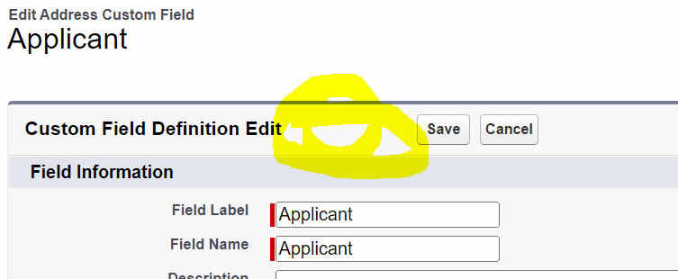



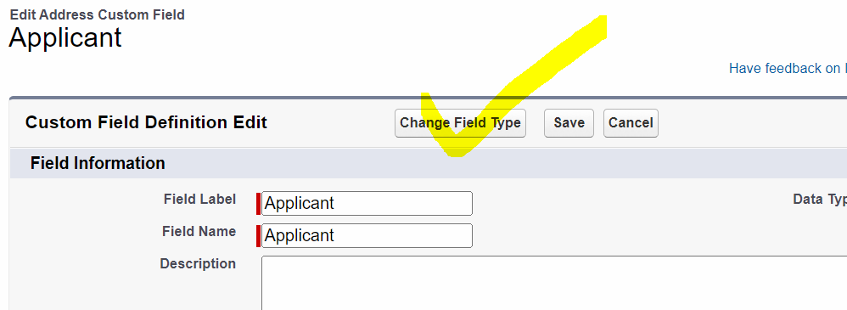

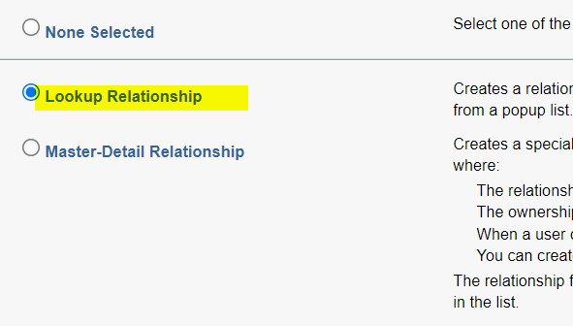

2] There are two Objects, Applicant 🡨 🡪 Passport. Relationship is in Lookup.

Can we convert Lookup Relationship 🡪 Master Details Relationship.

ANS: Yes, BUT 🡪 Every Child Record must have its related Parent associated.

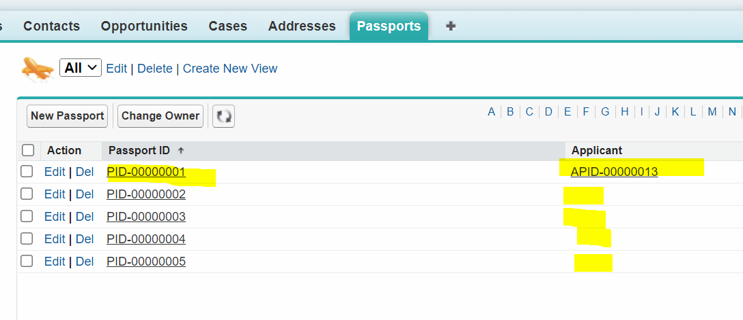

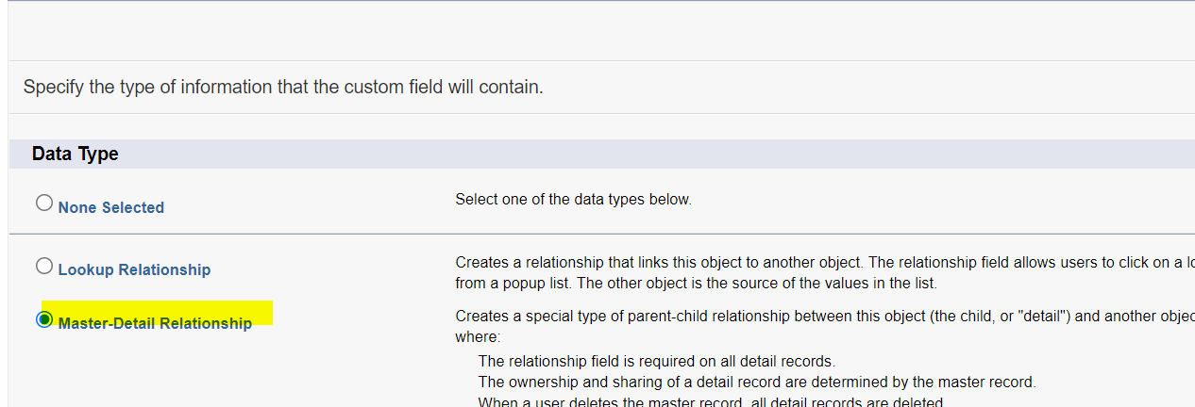





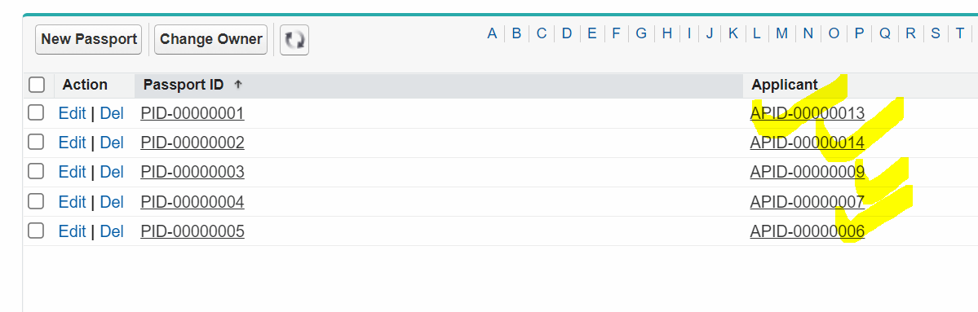

3] Gumaake



